Participant Manual
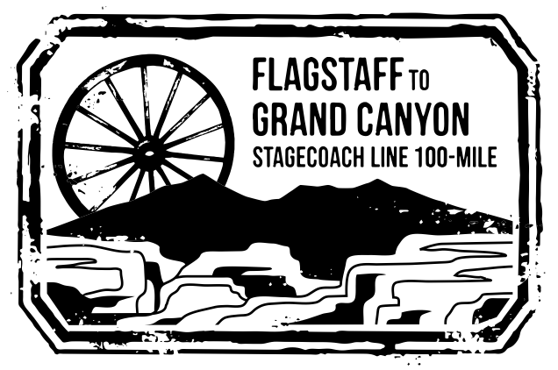
Flagstaff to Grand Canyon Stagecoach Line
100 Mile, 55K and Relays
____________________________________________
Flagstaff, Arizona
September 22-23, 2018
7AM
____________________________________________
Presented by Babbitt Ranches



Table of Contents

Welcome 3
Sponsors 4
Brief Course Description 5
Race Options 5
Qualifying 5
Start Times 6
Time Limits & Cut-Offs 6
Race Day Parking 6
Post-Race Transportation 6
Flagstaff, AZ 7
Tusayan, AZ 7
Travel 7
Accommodations 8
Race Weekend Weather 8
Our Partners 9
Awards 11
Race Weekend Agenda 12
Course Marking 13
Aid Stations 13
Drop Bags 14
Recommended Gear 15
Last Minute Supplies 15
Social Media & Runner Tracking 15
Aid Station Matrix: Distances, Relay Exchanges, and Services 16&17
Runner Rules 18
Pacer Rules 20
Crew Rules 21
Aid Station Driving Directions 23
Recommended Purchases 27
Detailed Course Description 28

©2018 The Flagstaff to Grand Canyon Stagecoach Line race is conducted under special use permit of the Coconino and Kaibab National Forests.

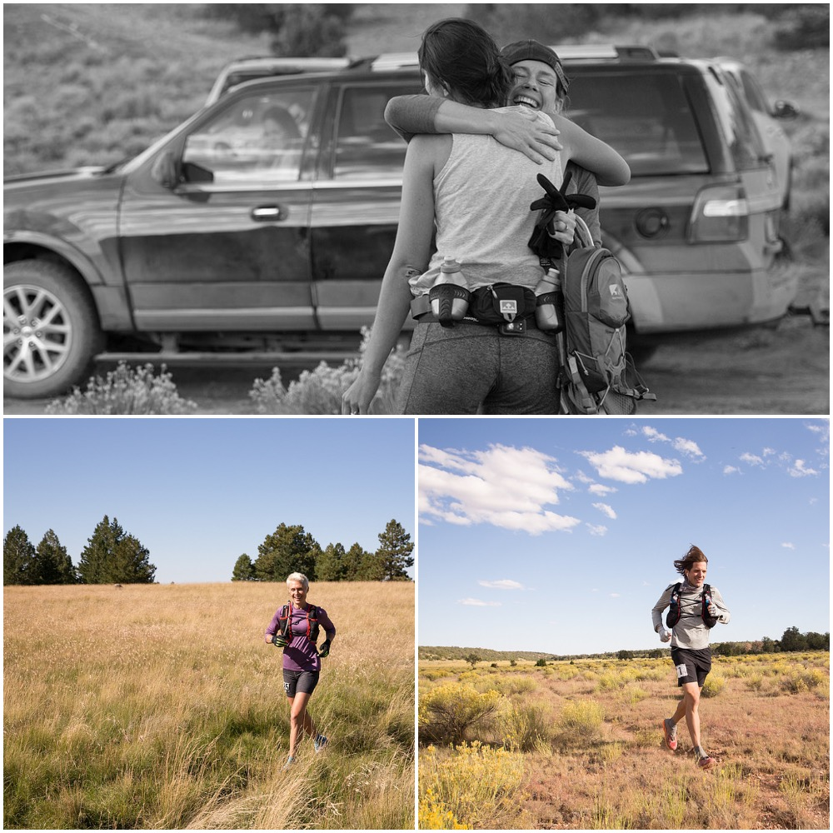

Top: Stagecoach Ethos; Bottom Right: Men’s 2017 100-Mile Winner Ron Hammett;
Bottom Left: Women’s 2017 100-Mile Winner Jess Mullen

Race Management

Race Director Ian Torrence
Assistant Race Director Emily Torrence
Medical Director
Coconino County Sheriff’s SAR Coordinator Bart Thompson
Coconino Amateur Radio Club Coordinator Bill Smith
Timing & Tracking UltraLive.net

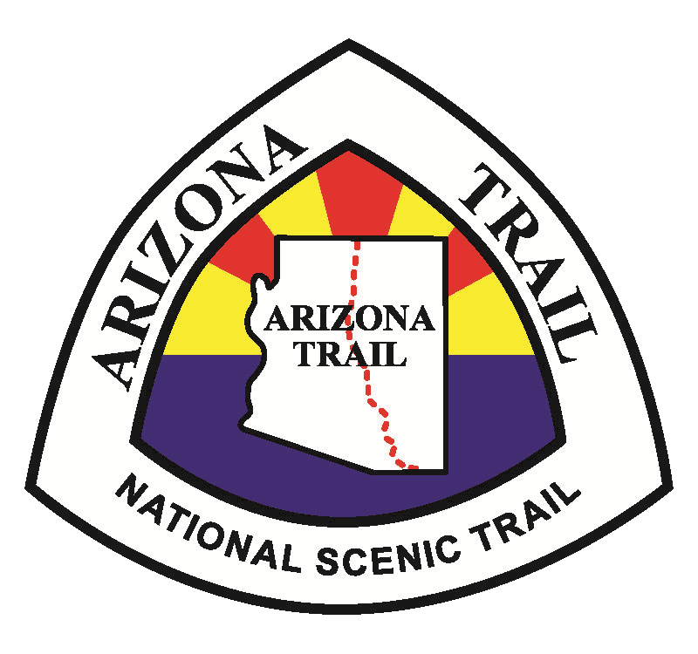


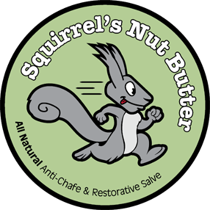

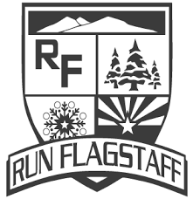




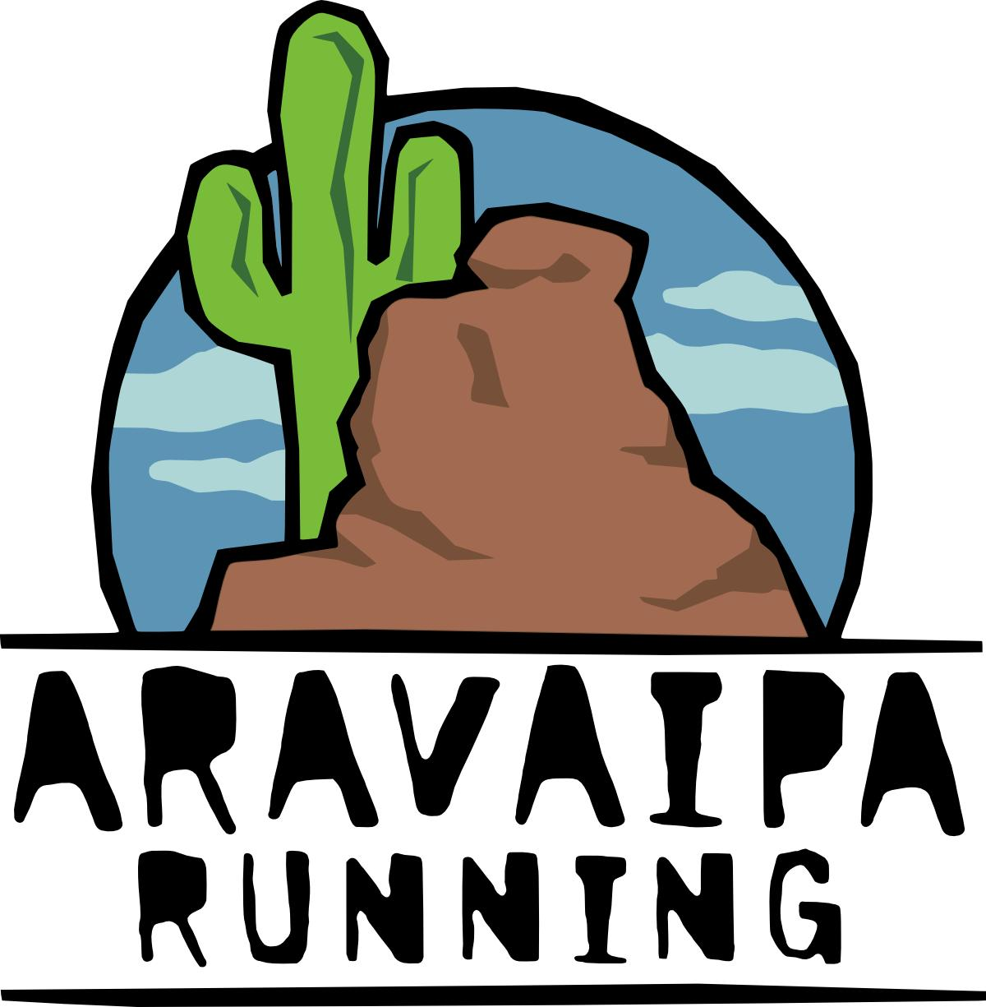





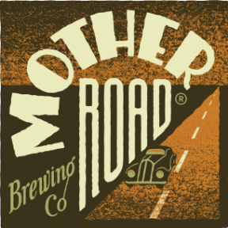

Brief Event Description

The race begins north of Flagstaff, Arizona, at the Flagstaff Hotshots Ranch near Snowbowl Road and finishes in Tusayan, Arizona, the entrance of the Grand Canyon National Park. A majority of the Stagecoach course follows the Arizona Trail and the historic Flagstaff to Grand Canyon Stage Line route used by adventure seeking tourists between 1897 and 1901. Many of today’s race-day aid stations are located at the original stage line rest stops and watering holes.

Course footing varies from single-track to two-track and forest dirt roads. Runners pass from heavily vegetated ponderosa pine and alpine aspen forests to sparsely vegetated pinion-juniper grasslands and back again. The course starts at 7,400’ (Hotshots Ranch), reaches a maximum elevation of 8,800’ (at Aspen Corner, mile 6), finishes at 6,600’ (Tusayan), and has approximately 7,000’ of climbing.

Runners traverse over a shoulder of Arizona’s highest mountain, Humphrey’s Peak, through the high alpine meadows of the Hart Prairie Preserve, across 422-square mile Babbitt Ranch, and along the Coconino Rim where views of the Grand Canyon, Painted Desert and Navajo Mountain await.

Race Options

- 55K solo (finishes at Cedar Ranch)
- 100 Mile solo (finishes at Tusayan Grand Canyon IMAX Theater)
- 55K 3-person relay (leg lengths in order and approximate mileages: 10.5, 10.5, 13)
- 100-mile 2-person relay (54.5, 45.5)
- 100-mile 4-person relay (34, 20.5, 26, 19.5)
- 100-mile 6-person relay (21, 17.5, 16, 13, 13, 19.5)
- 100-mile 8-person relay (10.5, 10.5, 17.5, 16, 13, 13, 7.5, 12)

Qualifying

There are no qualifying standards for the Stagecoach 100 Mile solo event. We trust you, as an athlete, to know your own abilities and to be the best judge of your fitness. A word of caution: This is not a race for beginners. We highly recommend that you have a few ultra events under your belt before toeing this starting line. Much of the event takes place above 7,000 feet. Expect all types of weather: wind, rain, hail, lightning and snow. Trail conditions may be wet and slippery and the terrain mountainous and rocky. You will encounter wild animals and/or cattle. A large portion of the event occurs at night. You will be greeted with a well-marked and challenging mountain run through alpine vegetation, spectacular autumn scenery, terrific aid stations and an opportunity for you, your family, and your friends to visit one of the greatest places in America — Northern Arizona, home of the fantastic little town of Flagstaff and the Grand Canyon.
Start Times

In order to alleviate congestion on the narrow Arizona Trail in the early miles of the race and to group finishing 100-mile soloists and relay teams there will be three start waves.

Saturday Start Times:
100-Mile Solo Runners: 7:00AM
55K Solo Runners: 7:15AM
100 Mile Relays & 55K Relays: 8:00AM

Time Limits & Cut-Offs

Time Limits:
100-mile solo runners: 31-hour time limit
100-mile relay teams: 30-hour time limit
55K solo runners: 9-hours and 15-minute time limit
55K relay teams: 8-hours and 30-minute time limit

Cut-Offs for all events:
Kelly Tank (mile 21): 2:00PM Saturday
Cedar Ranch (mile 33): 4:30PM Saturday
Boundary (mile 55): Midnight Saturday
Russell Tank (mile 68): 4:00AM Sunday morning
Hull Cabin (mile 80): 8:00AM Sunday morning

Race Day Parking

If you plan on leaving your vehicle at the start we must shuttle and park your vehicle at a parking lot at the northeast corner of Highway 180 and Snowbowl Road (about a mile from the start). We cannot leave any vehicles parked at Hotshots Ranch. The gate to the ranch will be locked after the event begins. If you fall into this category, let the race director know (itgoes@aol.com) and we’ll set up the appropriate shuttles on race morning. Please allow an additional 20 minutes for this process.

Post-Race Transportation

There are no official or organized shuttles that return to Flagstaff from the 55K or 100-mile finishes. However, we have never left anyone stranded! If you’re in need of a ride, we encourage you to use Stagecoach’s Facebook Page, the Flagstaff Ultra Club Facebook Page or Stagecoach’s UltraSign Up message board to find others that are available to bring you back. If you are unable to find a ride back to Flagstaff contact the race director (itgoes@aol.com). NOTE: Arizona Shuttle does provide daily shuttles from the Tusayan IMAX to downtown Flagstaff: http://arizonashuttle.com/schedules/flagstaff-grand-canyon/

About Flagstaff, Arizona

Often referred to as “The City of Seven Wonders,” 45-minutes North of Sedona and 90-minutes South of the Grand Canyon, lies Flagstaff, AZ. Permanently settled in 1876, the Atlantic and Pacific Railroad reached Flagstaff in 1882. In 1894, Lowell Observatory was built. In 1899, the University of North Arizona was founded. Flagstaff became the first night sky city, a movement started in 1958 to celebrate, promote and protect the dark skies of Flagstaff and northern Arizona. Flag’s estimated population stands at over 70,000 within city limits.

For several years, Flagstaff has been a training mecca for Olympians and aspiring athletes of many sports, but especially for running. In addition to the visiting athletes here for training camps, Flagstaff boasts its own year-round running community of all ages and ability levels. At the youth level, Kids Run Flagstaff and Flag’s high schools have stout programs with impressive participation numbers. Northern Arizona University (NAU) runners compete well at the collegiate level. Two resident elite training groups also call Flagstaff home. Northern Arizona Elite, led by Ben Rosario, has been a force to be reckoned with on the national level. Team Run Flagstaff’s own Team Run Flagstaff PRO features a unique blend of elite road and ultrarunners. While the elite teams are impressive, they wouldn’t be possible without a strong running community behind them. Here are the organizations that complete Flagstaff’s running stronghold:

- Northern Arizona Trail Runners Association (NATRA) http://www.natra.org/
- Team Run Flagstaff (TRF) http://www.teamrunflagstaff.com/
- Flagstaff Ultra Club (FUC) https://www.facebook.com/groups/178260948898834/

About Tusayan, Arizona

Tusayan, AZ, the “gateway to the Grand Canyon,” was originally privately owned in the early 1900’s by Forest Service ranger George Reed before the Grand Canyon was designated a National Park in 1919. Tusayan is located a mile south of the Grand Canyon National Park entrance and sits at an elevation of 6,612 feet. It has an estimated population of 600. Recently, Tusayan, bordered by the Kaibab National Forest, became an official gateway community for the Arizona National Scenic Trail. This town hosts the finish line of the Stagecoach 100 Mile.

Travel to Flagstaff

- Fly directly to Flagstaff’s Pulliam Airport (FLG): http://www.flagstaff.az.gov/?NID=1541
- Fly into Phoenix, AZ at Skyharbor International Airport (PHX) (a 2.5-3 hour drive north to Flagstaff): https://skyharbor.com/
- Use Arizona Shuttle from Skyharbor International Airport to Flagstaff (reservations recommended): http://arizonashuttle.com/
- Fly into Las Vegas, NV at McCarran International Airport (3.5 to 4 hour drive to Flagstaff): https://www.mccarran.com/

Accommodations in Flagstaff

- Snowbowl Ski Lift Lodge and Cabins – Located less than a mile from the start line and ~7 miles from Downtown Flagstaff
http://www.arizonasnowbowl.com/lodging/
- Drury Inn and Suites - https://www.druryhotels.com/PropertyHotelServices.aspx?property=0139
- Fairfield Inn by Marriott - http://www.marriott.com/hotels/travel/flgfi-fairfield-inn-flagstaff/
- Embassy Suites - http://embassysuites3.hilton.com/en/hotels/arizona/embassy-suites-flagstaff-FLGESES/index.html
- La Quinta Inn and Suites - http://www.laquintaflagstaff.com/
- Budget Inn - http://www.budgetinnflagstaff.com/
- Knights Inn - http://www.knightsinn.com/hotels/arizona/flagstaff/knights-inn-flagstaff/hotel-overview
- Weatherford Hotel – http://weatherfordhotel.com/
- Hotel Monte Vista - http://www.hotelmontevista.com/

Accommodations in Tusayan

- Best Western Premier Grand Canyon Squire Inn - http://www.grandcanyonsquire.com/
- Red Feather Lodge - http://www.redfeatherlodge.com/
- Holiday Inn Express & Suites Grand Canyon - http://www.ihg.com/holidayinnexpress/hotels/us/en/grand-canyon/gcnaz/hoteldetail
- The Grand Hotel at the Grand Canyon - http://www.grandcanyongrandhotel.com/
- Canyon Plaza Resort - http://www.grandcanyonplaza.com/

Race Weekend Weather

The average high in northern Arizona in mid-September is ~70 degrees. The average low is ~35. Temperatures will be cooler at higher elevations so be prepared! Sunrise is approximately 6:20 am and sunset is 6:20 pm. There could be wind, rain, snow, hail and thunderstorms. Always dress accordingly and be prepared for the weather to change at a moment’s notice. Check the latest weather reports as race day approaches.
Our Partners

There are several groups and organizations that we are indebted to that have made Stagecoach a reality.

1) Arizona Trail Association

The Arizona Trail Association (ATA) is the nonprofit organization whose mission is to build, maintain, promote, protect and sustain the Arizona Trail as a unique encounter with the land. Established in 1994, the ATA has been the driving force behind the vision, construction, and protection of the Arizona Trail.

Spanning the entire state of Arizona from Mexico to Utah, the Arizona Trail travels through some of the most breathtaking landscape in the West – from the grasslands of the southern part of the state, up and down the sky island mountain ranges, through Saguaro National Park, climbing up the Mogollon Rim, across the Colorado Plateau, through Flagstaff and along the base of the San Francisco Peaks, through the heart of Grand Canyon and across the Kaibab Plateau to the Utah state line, the Arizona Trail offers unparalleled adventure for hikers, runners, backpackers, mountain bikers and equestrians. It was designated as a National Scenic Trail in 2009.

The majority of the Arizona Trail was constructed by volunteers, and the organization relies on thousands of volunteers each year to maintain the trail. Funds raised through membership, donations, special events, business partners and grants provide the majority of funding for trail projects. The Arizona Trail is a grassroots movement and you are invited to be part of it.

In addition to participating in this Ultra & Relay, please explore more of the Arizona Trail (no permits are needed unless you’re camping overnight in one of the National Parks) and get involved with the ATA. Together, we can sustain this amazing trail into the future.

Find out more and how you can become a member at: http://www.aztrail.org/

2) Babbitt Ranches

Babbitt Ranches is the producer of AQHA quarter horses, sold every July in the annual Hashknife horse & colt sale, and is home to the Coconino Plateau Natural Reserve Lands. The ranch lands, near Flagstaff, Arizona and the Grand Canyon, host a variety of wildlife and grazing for quarter horses and cattle. Established in 1886, Babbitt Ranches practices ecological ranching while maintaining western traditions. Roughly 20 miles of the course crosses Babbitt Ranches land on the Arizona Trail. Learn more at: http://babbittranches.com/

3) Hart Prairie Preserve

Surrounded by thousands of acres of cool forest and meadows, the 245-acre preserve is home to uncommon wildflowers, old-growth ponderosa pine, a rare grove of Bebb willows, herds of elk and deer, porcupine, prairie dogs, and more than 40 species of birds. The first aid station of this event is within the Preserve.

A local family donated Hart Prairie Preserve, with its historic lodge and charming guest cabins, to The Nature Conservancy in 1994, when they discovered that their property held a globally rare community of Bebb willow trees.

Much of the work at the preserve focuses on the Bebb willow community, the largest known in the world. Conservancy staff work closely with partners at the U.S. Forest Service, U.S. Geological Survey, and various departments at Northern Arizona University on ecological restoration activities in the surrounding National Forest. Learn more at:
http://www.nature.org/ourinitiatives/regions/northamerica/unitedstates/arizona/placesweprotect/hart-prairie-preserve.xml

4) Kaibab and Coconino National Forests

The Kaibab National Forest truly offers something for everyone! If you are anywhere near Northern Arizona, you won't want to miss the chance to visit this Forest. The Kaibab surrounds the Grand Canyon on the north and south. From canyons to prairies, peaks to plateaus, the Kaibab National Forest offers layers of opportunity for peace, solitude, and discovery. Find out more at: http://www.fs.usda.gov/kaibab

The Coconino National Forest is one of the most diverse National Forests in the country with landscapes ranging from the famous red rocks of Sedona to ponderosa pine forests, to alpine tundra on the summits of the San Francisco Peaks. Explore mountains and canyons, fish in forest lakes and wade in lazy creeks and streams. Find out more at: http://www.fs.usda.gov/coconino

5) Town of Tusayan

The town of Tusayan is located at the South Rim entrance to Grand Canyon National Park and plays host to our 100-mile ultra and relay finish line. It is located on State Route 64 about 50 miles north of Interstate 40. Tusayan offers visitors a great place to stay, eat, and play while they take in the spectacular vistas of one of the seven natural wonders of the world. From jeep tours to river rafting, helicopter tours to mule rides, your stay in Tusayan will be unforgettable.

Located just north of Tusayan, the Grand Canyon is 277 miles (443km) in length, 10 miles (16km) wide and a mile (1,737km) deep. The Grand Canyon is home to hundreds of bird, reptile and animal species. The geology of the Grand Canyon displays hundreds of millions of years in the life of our Earth and nowhere else can a geologic timeline be seen so readily. Visitors will want to make plans to see the Grand Canyon at either sunrise or sunset as the low angle of the sun makes the colors come alive. Learn more at:
http://grandcanyoncvb.org/
http://tusayan-az.gov/info.html

6) Coconino County Search and Rescue

The Coconino County Sheriff's Search and Rescue Unit is a volunteer arm of the Sheriff's Office involved in performing the Sheriff's statutorily mandated function of conducting or coordinating search and rescue operations within the county. CCSAR members will be strategically placed along the course and provide SAR and first aid services for the event. A deputy assigned as the Search and Rescue Coordinator supervises search and rescue operations. The Unit is trained by the Sheriff's Office to provide vital search and rescue services to the second largest county in the nation, which encompasses approximately 18,600 square miles of diverse and sometimes very remote rugged terrain. Learn more at: http://coconinosar.org/sarhome.html

7) Coconino Amateur Radio Club

The Coconino Amateur Radio Club (CARC) include members in the city of Flagstaff, Coconino County, and Northern Arizona. This volunteer group will be stationed at various aid stations along the course and providing runner tracking and race day communication for our event. Find out more at: http://www.cocoradio.club

Awards

100-Mile Awards:
- Locally made copper belt buckles for all finishers under the 31-hour cut-off.
- Special “Champion” buckles for the overall women and men winners.
- Babbitt Ranches Pendleton blankets for overall winners.
- Special awards for the men and women masters (over-40) winners.

55K and Relay Awards:
- Special finisher medals and awards for all 55K and relay team members supplied by Babbitt Backcountry.
- Special prizes for overall and masters (over-40) 55K winners.

We’ll also have other random giveaway prizes brought to you by Babbitt Ranches, Babbitt Backcountry, the Arizona Trail Association, RunFlagstaff and Salomon.

Race Weekend Agenda

Thursday September 20th – At Run Flagstaff - 204A East Route 66 Flagstaff, AZ 86001 (Next to Absolute Bikes) (928) 774-2990

6:00PM – Stagecoach Race Veteran Panel: Come ask your race questions and visit with some of the athletes who’ve won, run and volunteered at the event in previous years.

Friday, September 21st – At Run Flagstaff - 204A East Route 66 Flagstaff, AZ 86001 (Next to Absolute Bikes) (928) 774-2990

4:00PM-6:00PM –
- 100 Mile, 55K and Relay Team Packet Pick-up and Check-in
- 100 Mile and 55K Drop bag drop-off
- 100 Mile Pacer Check-In

Saturday, September 22nd – At the Flagstaff Hotshots Ranch (Start Line)

6:15AM-6:50AM –
- Mandatory 100 Mile solo, 55K solo and 55K Relay Team Check-In & Packet Pick-Up. All solo runners and 55K relay team captains must check in on Saturday before the start — even if you picked up your packet on Friday.
- 100 Mile and 55K Drop Bag drop-off
- 100 Mile Pacer Check-In

6:50AM – Mandatory pre-race informational briefing at the start line for 100-mile soloists, 55K soloists and 55K relay team captains.

7:00AM – 100-Mile Solo Runners Start

7:15AM – 55K Solo Runners Start

7:15AM – 7:50AM –
Mandatory 100-Mile Relay Team Check-In & Packet Pick-Up. All 100 Mile Relay Team captains must check in on Saturday before the start — even if you picked up your packet on Friday.

7:50AM – Mandatory pre-race informational meeting at start line for 100-Mile Relay Team captains

8:00 AM – 100-Mile & 55K Relays Start

4:30PM – 55K Course Closes at Cedar Ranch

Sunday, September 23rd – At the Tusayan Grand Canyon IMAX Theater (Finish Line)

10:00AM-2:00PM –
Awards, refreshments, food and cheer on relay teams and 100-mile solo finishers!

2:00PM – Course closes.
Course Marking

The entire 100-mile and 55K courses will be marked well. Marking will be more plentiful at turns and intersections. Confidence markers will be placed every quarter to half-mile when the trail is obvious. Remember much of the course follows the AZ Trail. Reflective tape & diamonds, orange ribbon, pin flags and arrow signs will be used. The use of a headlamp in the dark hours will be important so that you see the reflective material. Please visit the link below for specifics:

http://www.aztrail.org/ultrarun/2013_Stageline_100_Mile_Course_Marking.pdf

Aid Stations

Stagecoach offers 11 fully stocked and volunteer led aid stations. Though we wish we could, we cannot accommodate every runner’s need. Be prepared by using your own crew and drop bags to provide yourself with the items you require. Aid station fare will include:

- Tailwind Nutrition
- Squirrel’s Nut Butter
- Water
- Coke
- Ginger Ale or 7-Up
- Electrolyte pills
- Fruit (oranges, bananas)
- Boiled potatoes
- Various sandwiches (PB & J, ham, cheese)
- Potato Chips
- Candy
- Soup (vegetable broth, chicken noodle, tomato)
- Salt
- First aid kit

Drop Bags

1) Drop bags must be labeled with:
- Runner’s name
- Bib number
- Race distance (100 mile or 55K)
- Aid station name

2) Do not use paper drop bags as they will disintegrate when wet.

3) As we have many bags to transport, please keep your bag relegated to the approximate size of large shoebox (8” x 8” x 16”). However, Finish Line drop bags can be the size of a backpack to accommodate warm weather clothing, sleeping bags and/or tents.

4) 100-mile runners may retrieve their drop bags at the finish line in Tusayan after the event on Sunday. 55K runners may retrieve their drop bags at Cedar Ranch after the event on Saturday. Drop bags will not be mailed home.

5) 100-mile runners may place drop bags at these locations only:
- Kelly Tank (mile 21)
- Cedar Ranch (mile 34)
- Boundary (mile 55)
- Russell Tank (mile 68)
- Hull Cabin (mile 80)
- Watson Tank (mile 88)
- IMAX Finish (mile 100)

6) 55K runners may place drop bags at these locations only:
- Kelly Tank (mile 21)
- Cedar Ranch Finish (mile 34)

Recommended Gear

- Lightweight wind and water proof jacket and pants
- At least 2 flashlights and/or headlamps and new spare batteries
- Cell phone for emergency purposes (there is reception on much of the course)
- Warm gloves and hat
- Course maps and turn book
- Adequate hydration system that can carry the above equipment

Last Minute Supplies

Did you forget something? Our local running store and gear shop have it all.
- Run Flagstaff: http://www.runflagstaff.com/ (928) 774-2990
- Babbitt’s Backcountry: http://babbittsbackcountry.com/ (928) 774-4775

Social Media

#stagecoach100

Stagecoach’s event web site: http://www.aztrail.org/ultrarun/
Stagecoach’s Blog: http://flagstaff100andrelay.blogspot.com/
Stagecoach’s Twitter: https://twitter.com/Flagstaff100M/
Stagecoach’s Facebook: https://www.facebook.com/FlagstaffStagecoachLine100Mile
Stagecoach’s Flickr Photo Albums from past years: https://www.flickr.com/photos/152789721@N04/albums

2018 Live Race Day Tracking

Real-time race coverage will be provided by UltraLive.net.
Aid Stations, Distances & Amenities

Checkpoints | Distance | Segment Distance | Crew | Drop Bags | Pacer | Amenities | Cut-Offs
Hotshots Ranch | 0 | 0 | YES | NO | NO | Start
Hart Prairie | 9.5 | 9.5 | NO | NO | NO | Full Aid
Fern Mountain | 10.5 | 1 | YES | NO | NO | No Aid
Kelly Tank | 21 | 10.5 | YES | YES | NO | Full Aid | Sat. 2pm
Missouri Bill | 31 | 10 | NO | NO | NO | Water Only
Cedar Ranch | 34 | 3 | YES | YES | NO | Full Aid | Sat. 4:30pm
Tub Ranch | 38.5 | 4.5 | YES | NO | NO | Full Aid
Oil Line | 44.5 | 6 | NO | NO | NO | Full Aid
Boundary | 54.5 | 10 | YES | YES | YES | Full Aid | Sun. 12am
Moqui | 60 | 5.5 | NO | NO | NO | Full Aid
Russell Tank | 67.5 | 7.5 | YES | YES | YES | Full Aid | Sun. 4am
FR310 | 69.5 | 2 | NO | NO | NO | Water Only
Hull Cabin | 80.5 | 11 | YES | YES | YES | Full Aid | Sun. 8am
Watson Tank | 88 | 7.5 | YES | YES | YES | Full Aid
Reed Tank | 97.5 | 9.5 | NO | NO | NO | Fluids Only, Full Aid after Sunday 6am
Tusayan IMAX | 100 | 2.5 | YES | YES | YES | Finish | Sun. 2pm

Relay Exchanges and Distances Matrix continued on next page →
Relay Exchanges & Distances Matrix

Relay Exchanges & Distances | 55K 3-Person Relay Exchanges | 100M 2-Person Relay Exchanges | 100M 4-Person Relay Exchanges | 100M 6-Person Relay Exchanges | 100M 8-Person Relay Exchanges
Hotshots Ranch | 0 | 0 | 0 | 0 | 0
Fern Mountain | 10.5 |  |  |  | 10.5
Kelly Tank | 10.5 |  |  | 21 | 10.5
Cedar Ranch | 13 |  | 34
Tub Ranch |  |  |  | 17.5 | 17.5
Boundary |  | 54.5 | 20.5 | 16 | 16
Russell Tank |  |  |  | 13 | 13
Hull Cabin |  |  | 26 | 13 | 13
Watson Tank |  |  |  |  | 7.5
Tusayan IMAX |  | 55.5 | 19.5 | 19.5 | 12

100 Mile, 55K & Relay Runner Rules

The purpose of the rules are to ensure the event’s integrity, make certain that this is a test of individual performance, and provide an equal playing field for all. The guiding principles are simple: play fair, be safe, and respect the land.

Relay Runners:

- A relay runner may run as many legs as they deem necessary for their team.
- Relay exchanges are to take place at ONLY designated relay exchanges.
- Only one team’s relay runner can run each segment. Relay runner pacing is only allowed if the relay runner is over 60 years of age, has a handicap or the runner has special permission from race management.

All Runners:

- Each runner’s official bib number must be worn prominently on the front of the body and must be easily visible at all times.
- The event will be both chip timed (primary timing mode) and hand timed (back-up). Do not cut, bend or crumple your bib. This will damage the electronic chip and your finish time and place could be affected.
- Runners must follow the marked route at all times. Any runner departing from the official course must leave and return to the point of departure on foot before continuing.
- Except in case of medical emergency, runners may not accept aid or assistance in any form from anyone between checkpoints and aid stations.
- Runners may not store supplies of any kind along the trail.
- Runners are responsible for the actions of their crews and pacers. Everyone associated with the event must comply with all event rules (Runner Rules, Pacer Rules, Crew Rules) and regulations issued by the race director in pre-race memos and at the pre-race briefing on Saturday morning. All parking and access instructions must be followed as well or risk disqualification of the runner.
- Each runner must be checked IN and checked OUT of all checkpoints and aid stations.
- All cut-off times will be strictly enforced. Runners must be checked OUT of the checkpoint BEFORE the cut-off time. Runners returning to the checkpoint after the cut-off time will be pulled from the race.
- There is no pre-race weigh-in or medical exam. However, all runners may undergo brief medical examinations at designated checkpoints. Additional monitoring of individual runners may be required at the discretion of medical personnel. Refusal by the runner to cooperate fully may result in immediate disqualification. Medical personnel have complete authority to evaluate the condition of any runner at any time and to determine whether the runner may continue.
- In addition to information provided by the runner in the race application’s medical questionnaire, each runner must fully disclose to medical personnel at the pre-race check-in any changes to existing medical conditions and all prescription medications being taken.
- Injection of fluids or drugs (intravenous, intramuscular, subcutaneous) during the event may result in immediate disqualification.
- The Stagecoach Line 100 Mile, 55K and Relay is committed to keeping ultrarunning a clean, drug-free sport. Use of performance-enhancing drugs or blood doping as defined by the USADA is forbidden.
- Littering of any kind is prohibited. Please respect the natural beauty of our trails and the right of everyone to enjoy them. Littering will threaten our continued use of the Arizona Trail, Hart Prairie Preserve, Babbitt Ranch, and USFS Lands.
- Bad sportsmanship will not be tolerated.
- Smoking is not permitted at any of the checkpoints or along the trail.
- Any runner who is unable to finish the race must personally inform the aid station captain of the nearest checkpoint of his/her decision to withdraw. Runners who leave the course without notifying a race official will be classified as “lost,” thereby activating the Coconino County Sheriff’s Search and Rescue Unit. Time spent searching for any such runner will be billed to the runner, a VERY expensive proposition.
- Runners or relay teams crossing the finish line after the 31-hour cutoff will not be listed as official finishers.
100-Mile Pacer Rules

- A pace runner, or pacer, is defined as a “trail companion” who may accompany a runner along designated sections of the trail.
- Pacers should be experienced trail runners in excellent physical shape and conditioned adequately to run the distance they are to pace. Pacers should be adequately supplied with flashlights, food, and water. They may partake in all the aid station amenities like the registered runner they are pacing.
- 100-mile runners may begin to use pacers at Boundary Aid Station (mile 54). 55K runners will NOT be allowed pacers.
- However, 100 mile and 55K runners over 60 years of age or those with certain medical conditions or handicaps may have a pacer from start to finish. Examples include seizure disorders or vision issues.
- One pacer at a time may accompany each 100-mile runner from the Boundary (mile 54), Russell Tank (mile 67), Hull Cabin (mile 80) or Watson Tank (mile 88) aid stations to the finish.
- Pacers may be switched at Russell Tank, Hull Cabin and Watson Tank only.
- For those runners who are paced for the entire 100 mile distance, pacer changes can be made at: Kelly Tank, Cedar Ranch, Boundary, Russell Tank, Hull Cabin and Watson Tank.
- Each pacer MUST sign a release form and pick-up a pacer bib at race check-in on Friday, the start, Boundary, Russell Tank, Hull Cabin or Watson Tank aid stations before they begin pacing.
- Each pacer must wear the official identifying pacer bib. One pacer number is provided per entrant. The official pacer bib must be transferred between pacers if duties for one runner are to be shared.
- All pacers must clearly identify themselves when passing through checkpoints. It is extremely important that personnel know exactly who is on the trail and where.
- Pacers must stay with their runners at all times, except in the case of an emergency. If the runner withdraws from the race, and the pacer wishes to continue, she must remain at the aid station until another runner enters the aid station and requests the services of a pacer. The pacer may not continue on without an official race participant.
- Pacers must enter and leave each aid station WITH their runners. They may assist with the re-filling of water bottles or replenishment of supplies while in the station. “Muling” (carrying gear or supplying aid outside of aid station line of sight) is prohibited.
- No mechanical or physical assistance may be given by the pacer to the runner at any time.
- Pacers must remain behind their runner. Let the runner find their way.
- Please respect the trails; littering of any kind is strictly prohibited.

100-Mile, 55K & Relay Crew Rules

100-mile, 55K and relay team crews must follow all of the rules and regulations of the race, including the Runner Rules, Pacer Rules, and the following Crew Rules and any supplementary instructions issued in any pre-race memos or at the Saturday morning briefing. All crew members must willingly comply with all instructions from race personnel, volunteers and race management at all points along the trail and its access routes, including parking regulations, or risk disqualification of their runner.

- A crew member is defined as any individual who provides material support to a runner in the event.
- Crews may meet runners or assist them only at those aid stations specifically designated for crews.
- Crews must adhere to instructions of all aid station personnel and volunteers, including requests to vacate a certain area of the checkpoint.
- Crews must stay within a 200-yard radius of the aid station while attending to their runners.
- Crews are NOT allowed at the following checkpoints: Hart Prairie Preserve, Oil Line, Moqui Stage Station, the turn to and from Hull Cabin on FR 307 (Please proceed to Hull Cabin), and Reed Tank.
- You may NOT crew your runner at non-aid station locations.
- Crews will NOT be allowed to travel across Babbitt Ranch land from Cedar Ranch to Boundary Aid Station. Please use the directions provided in the section below! Only crew and relay vehicles with passes will be allowed to pass from Cedar Ranch to Tub Ranch aid stations. They will also have to return to Cedar Tank and proceed on to Boundary via the directions described below. This is to preserve runner safety and enjoyment.
- PLEASE!!! Crews must always drive at safe speeds! No matter how fast your runner may be, it is possible for crews to arrive at all the major checkpoints without exceeding the posted speed limits. Speed limits are rigidly enforced. Slow speeds will also keep dust down.
- Crews must never park in such a way as to block traffic, access to the trail or checkpoint, or other parked cars. Vehicles will be towed at the owner’s expense, and their runner may be immediately disqualified.
- NO SMOKING WILL BE ALLOWED AT ANY OF THE CHECKPOINTS OR ALONG THE TRAIL.
- Littering of any kind at any checkpoint, along the trail, or at the finish line is strictly prohibited.

Aid Station Access:

- Access roads must remain open at all times for emergency vehicles.
- Drive slowly and carefully. Beware of runners on FR 307 to Hull Cabin, FS301 (runners cross the dirt road) to the Boundary aid station, and between Cedar Ranch and Tub Ranch on FR 9008A as cars and runners share the course. Please, driving slow here will keep the dust down!
- Allow plenty of time for travel.
- Cooperate with traffic control officials.

Plan To Take Care of Yourself:

- Eat regular meals and hydrate regularly.
- Wear appropriate clothing and pack proper bedding and shelter.
- Have headlamps at the ready as many of the race’s miles will be covered at night.
- We recommend four-wheel drive or all-wheel drive vehicles for this event.
- Cell service is available along much of the course.

Start, Finish, Crew & Relay Driving Directions:

To Start (Flagstaff Hotshots Ranch):
35.284667, -111.724177
- From downtown Flagstaff, take Highway 180 North approximately 7 miles (from the intersection of Humphreys Street and Route 66) to Snowbowl Road.
- Take a right onto Snowbowl Road.
- Drive one mile. If you reach the right hand curve in the road you’ve gone about 100 meters too far.
- Turn left onto dirt road (look for the blue Hotshots sign).
- Follow the dirt road back and follow the parking monitors instructions.

To Hart Prairie Preserve (sponsored by iRun): Aid Only – No Crew Access

To Fern Mountain (Crew, 55K 3-person & 8-person Relay Exchanges):
- From Hotshots Ranch (the Start), turn right (south) on Snowbowl Road and drive one mile back to Highway 180.
- Turn right (north) on Highway 180 and drive ~8 miles.
- Turn right (east) on FR 794.
- Take FR 794 ~2.4 miles to a large clearing on your left. Park in this field.
- Continue to the exchange by walking east on FR 794 another 0.3 miles to its intersection with FR 151. This is the exchange and crew point.

To Kelly Tank (sponsored by the Arizona Trail) (Crew, 55K 3-person, 6- & 8-person Relay Exchanges):
35.419430, -111.703900
- From the Hotshots Ranch (Start), drive south on Snowbowl Road, back to Highway 180.
- Turn right (north) on Highway 180 and drive ~13.5 miles.
- Turn right on FR 514 (just before the White Buffalo buildings - now burnt remains) in the middle of wide-open Kendrick Park.
- Continue 3 miles on dirt road to the Kelly Tank aid station.

To Cedar Ranch (sponsored by Babbitt Ranches) (55K Solo and Relay finish, Crew and 4-person Relay Exchange): 35.547330, -111.782920
- From Kelly Tank aid station return to Highway 180 and turn right (north).
- Travel 13.1 miles. Just past mile marker 248 (If you reach the Kaibab USFS sign you’ve gone about a quarter mile too far) to FR 417 and turn right.
- Travel 5.2 miles on dirt FR 417 and arrive at the Cedar Ranch aid station. Do not drive up the hill to the buildings, stay left and low at the intersection to get to the aid station. There is very weak cell service here, however, there is good reception a few miles back on FR 417.

To Tub Ranch (sponsored by Aravaipa Running) (Crew and 6- & 8-person Relay Exchanges):
35.599060, -111.757390
You’ll be sharing the road with the runners at this point. Please drive slowly and with great care!!! You must have a pass to travel to this aid station.
From Cedar Tank take FS 9008A north to Tub Ranch 4.5 miles.

To Oil Line (sponsored by Babbitt’s Backcountry): Aid Only – No Crew Access

To Boundary Aid Station (sponsored by Squirrel’s Nut Butter) (Crew, Pacers and 2-, 4-, 6-, & 8-person Relay Exchanges): 35.745120, -111.817270
NOTE: For the drive to this aid station we highly recommend the use of a four-wheel drive or all wheel drive vehicle. FR 301 is a barely maintained single-lane road. There are some tight turns, deep ruts, and rocks that may need negotiating. You will make it safely, but care and the right vehicle will make your life and ours much easier. Drive slowly as runners do cross this road once in this section.
- From Tub Ranch return to Cedar Ranch and then back to Highway 180.
- Turn right (north) and proceed to State Route 64. This intersection is in the town of Valle, AZ (there is a reliable gas station here).
- Go north on SR-64/US-180 for 11 miles to FR 320 (mile marker 224). This turn is also located ~11.5 miles south of the town of Tusayan and 56.0 miles north of Flagstaff.
- Turn right (east) onto FR 320.
- Continue east on FR 320 for ~16 miles to its intersection with FR 301 (if you get to the Bucklar Landing Strip you’ve gone about a mile too far).
- Turn right (south) on FR 301.
- In 3 miles you’ll pass under large power lines. In another 0.5 miles you’ll pass the Moqui Stage Aid Station (on your left). Do not stop here, this is NOT a crew accessible aid station.
- Continue from here for ~5 miles on FR 301 to the Boundary Aid Station (~8 miles from the intersection with FR 320).
- Cross through the fence at the aid station and follow the signs to parking in the field on the right.

To Moqui Stage Station: Aid Only - No Crew Access

To Russell Tank (sponsored by Sedona Running Company) (Crew, Pacers, 6- & 8-person Relay Exchanges):
35.873170, -111881000
From Boundary Aid Station:
- Retrace your steps, passing the Moqui Stage Station and under the power lines.
- Once you return to FR 320, turn right (east).
- In less than a mile turn left (north) on FR 311, near the Bucklar Landing Strip.
- Continue on FR 311 for 3.3 miles and turn right onto FR 311A to the Russell Tank. The turn is signed.

From Cedar Ranch Aid Station:
- Return to Highway 180.
- Turn right (north) and proceed to State Route 64. This intersection is in the town of Valle, AZ (there is a reliable gas station here).
- Go north on SR-64/US-180 for 11 miles to FR 320 (mile marker 224). This turn is also located ~11.5 miles south of the town of Tusayan and 56.0 miles north of Flagstaff.
- Turn right (east) onto FR 320.
- Continue east on FR 320 for ~17 miles to its intersection with FR 311 near the Bucklar Landing Strip.
- Turn left (north) on FR 311.
- Continue on FR 311 for 3.3 miles and turn right onto FR 311A to the Russell Tank. The turn is signed.

Access to Russell Tank Aid Station is also available through Grand Canyon National Park, but an entrance fee must be paid ($30).
- From the Grand Canyon South Entrance Station follow state Route 64 east toward Desert View.
- Two miles past Grandview Point, turn right onto a gravel road (there are usually a few large dumpsters here).
- This road becomes FR 310 at the park/forest boundary line.
- Pass the Grandview Fire Tower and follow FR 310 (Coconino Rim Road) for 8.3 miles from the boundary to FR 311.
- Turn right and drive 1.7 miles to the left turn into Russell Tank indicated by signs.

To Hull Cabin (sponsored by Northern AZ Trail Running Association) (Crew, Pacers, 4-, 6- & 8-person Relay Exchanges):
35.9683, -111.94639
- From Russell Tank Aid Station head north on FR 311 for 1.7 miles to the Coconino Rim Road (FR 310).
- Turn left (north) on FR 310.
- Travel 6.5 miles to FR 307.
- Turn right (east) on FR 307.
- Continue on FR 307 (down the hill) for 1.5 miles to Hull Cabin’s driveway (past Hull Tank).
- Turn left into the driveway by following the signs, through a gate and onto the cabin at the end of the driveway.

Access to Hull Cabin is also available through Grand Canyon National Park, but an entrance fee must be paid ($30).
- From the Grand Canyon South Entrance Station follow state Route 64 east toward Desert View.
- Two miles past Grandview Point, turn right onto a gravel road (there are usually several large dumpsters located here).
- This road becomes FR 310 at the park/forest boundary line.
- Pass the Grandview Fire Tower and follow FR 310 (Coconino Rim Road) for less than a half-mile and turn left (east) on FR 307.
- Continue on FR 307 down the hill for 1.5 miles to Hull Cabin’s driveway.
- Turn left and follow the signs for Hull Cabin.

To Watson Tank (sponsored by Desert Dash) (Crew, Pacers, 8-person Relay Exchange):
- From Hull Cabin Aid Station, return to FR 310 via FR 307.
- Turn left or south on FR 310.
- Travel ~1.3 miles south on FR 310 and turn right (west) on FR 302.
- Follow FR 302 for ~8.75 miles to FR 303.
- Turn right (north) on FR 303.
- Follow FR 303 ~2.8 miles to the Watson Tank Aid Station.

From Tusayan:
- Find FR 302 located just north (and on the east side of SR-64/US-180) of the southern most roundabout in town.
- Take FR 302 (dirt road) for ~5.5 miles east to the second FR 303.
- Turn left or north on FR 303 for ~2.8 miles to the Watson Tank aid station.

To Reed Tank (Sponsored by Southern Arizona Road Runners): Aid Only – No Crew

To Finish (Tusayan Grand Canyon IMAX):
Address: 450 State Route 64, Tusayan, AZ 86023.
- From Hull Cabin Aid Station take FR 307 back to FR 310.
- Turn right on FR 310 (north) and drive to State Route 64 (you’re now in the Grand Canyon National Park).
- Turn left (west) on SR-64.
- Travel 10.7 miles to US-180 (South Entrance Road).
- Travel south on South Entrance Road 6 miles to the Tusayan IMAX Theater on the right (west side of the road). The race’s finish line is in the gravel lot north of the IMAX building.

From Watson Tank Aid Station:
- Travel south on FR 303 for ~2.8 miles.
- Turn right (west) on FR 302.
- Continue on FR 302 5.5 miles to Tusayan and SR-64. Take a right (north) on SR-64 through town.
- The IMAX is located on the left (west side of the road) in about a half-mile. The race’s finish line is in the gravel lot north of the IMAX building.

Recommended Purchases

Here are a few apps, maps and books that will help you find your way.

We HIGHLY recommend downloading and utilizing the Arizona Trail App:
http://www.aztrail.org/apps.html

Emmitt Barks Cartography Flagstaff Trails Map:
http://www.emmittbarks.com/maps.htm

Coconino National Forest Map:
http://www.fs.usda.gov/main/coconino/maps-pubs

Kaibab National Forest Map:
http://www.fs.usda.gov/main/kaibab/maps-pubs

Your Complete Guide to the Arizona National Scenic Trail:
http://www.aztrail.org/store/at_store.php

You can also download maps and information for free at: http://www.aztrail.org/passages/passages.php
Detailed Course Description:

- We highly suggest that you print out, get familiar with and use (in conjunction with the course maps) the race’s turn book: http://www.aztrail.org/ultrarun/Flagstaff_to_Grand_Canyon_Stagecoach_Line_100M_Turnbook.pdf
- Also we suggest that you download and utilize the Arizona Trail App:
http://www.aztrail.org/apps.html

Miles 0-20 - Hotshots to Kelly Tank:

The course leaves Hotshots ranch on two-track that quickly becomes a rough rarely used game trail. This game trail will be well marked, lasts for less than a half-mile, but takes you to the well-maintained Arizona Trail (AZT). Turn left at the AZT and head north and uphill towards the Grand Canyon. This is the longest climb of the race. In 4 miles you’ll gain ~1,300’. Once at Aspen Corner turn left and run downhill past Alfa Fia Tank, through a few fences (close all gates) to Forest Road (FR) 151.

Once at the well-used and maintained FR151, turn right and north. Take FR151 to Hart Prairie Preserve. Enter the Preserve (on the right) run to the aid station located at the lodge and then reverse direction back to FR151. Back on FR151 turn right (north), pass the Fern Mountain relay exchange and continue on to FR627 to Bismark Lake. Turn right on FR627. The road ends at a parking area, continue straight on the trail to Bismark Lake and the AZT. Turn left (north) on the AZT and enjoy the long downhill sweeping switchbacks through the spruce, fir, ponderosa and aspens. Cross FR418 and continue downhill to Kelly Tank aid station.

For photos of this section please refer to the race’s blog link here:
http://flagstaff100andrelay.blogspot.com/2013/08/course-preview-miles-0-20.html

For maps of this section, please see the links below:
Map 1 - Start to Hart Prairie
Map 2 - Hart Prairie to Kelly Tank

Miles 21-60 - Kelly Tank to Moqui Stage Station:

Leave Kelly Tank, cross FR514 and follow the AZT north. The trail will parallel FR514 until it swings more northerly, crosses 523 and joins FR416. Follow FR416 north and leave the large ponderosa trees behind you as you enter pinion and juniper forests. FR416 will descend, gently at first and then more steeply and rockier later, to Babbitt Ranch. Once on the flat grasslands below turn left on FR417 and follow the rough two-track road to the Cedar Ranch aid station. 55K runners and 3-person 55K relay finish at Cedar Ranch.

Head north from Cedar Ranch on well maintained FR9008A. Enter Babbitt Ranch and follow the road, course markings and AZT markers to the Tub Ranch aid station. Leave Tub on the well-maintained road, climb a small hill, pass Rabbit Tank on your left, and follow the well-maintained dirt road for almost 6 miles. Just before crossing under some tall power lines, veer right (follow AZT signs and course markings) onto a two-track road to Oil Line aid station.

From Oil Line continue north on the AZT on two-track road (rough at times). Pass around Upper Lockwood Tank (gate) and Lockwood Tank (gate) on the AZT. Climbs are small and terrain mostly flat. Follow the two-track road and AZT to Boundary Aid Station.

Leave Boundary heading north on the AZT. The trail immediately leaves the road and returns to single-track. This section has some rough footing and passes over several small juniper and pinion ridges. Cross over FR301 and continue north to the very short out-and-back to Moqui Stage Station aid station. The turn is well signed. Turn left and go the quarter-mile to Moqui aid station.

For photos of this section please refer to the race’s blog link here:
http://flagstaff100andrelay.blogspot.com/2013/08/course-preview-miles-20-59.html

For maps of this section, please see the links below:
Map 3 - Kelly Tank to Cedar Ranch
Map 4 - Cedar Ranch to Oil Line
Map 5 - Oil Line to Boundary
Map 6 - Boundary to Moqui

Miles 60-80 – Moqui Stage Station to Hull Cabin:

Leave Moqui aid station and return to the AZT and go left and north. Cross FR313, continue north on smooth two-track, cross FR320. Close all gates. Continue north on the AZT. The two-track becomes single-track; the pinion-juniper gives way to large ponderosa trees and leads to the Russell Tank aid station. The deep Russell Tank will be on the right and the aid station on the left.

Leave Russell Tank and continue north on the AZT. Cross FR310 (Coconino Rim Road). The AZT now traverses across the top rim of the Coconino Rim. The Painted Desert, Grand Canyon and Navajo Mountain are visible at times. This is a gently rolling section of trail. Use the “bike detour route” which will bring you briefly back to FR310. Follow the “detour” around the small canyon and back into the woods to the AZT proper. Close all gates. Arrive at FR307. Turn right on FR307, run downhill, pass Hull Tank on the left, and then turn left to the Hull Cabin aid station.

For photos of this section please refer to the race’s blog link here:
http://flagstaff100andrelay.blogspot.com/2013/08/course-preview-miles-59-80.html

For maps of this section, please see the links below:
Map 7 - Moqui to Russell
Map 8 - Russell to Hull

Miles 80-100 - Hull Cabin to Tusayan IMAX:
Leave Hull Cabin and return to the AZT the way you came, uphill on FR307. Turn right (north) on the AZT, pass along a small interpretive trail and under the Grand View Fire Tower. Pass through a small parking lot and across FR310 to the single track AZT on the other side. Follow the AZT to signed Watson Tank, join a dirt road and follow the AZT signs and course markings another half-mile to the Watson Tank aid station.

Leave Watson Tank aid station following the AZT, veer right off of FR303 on the marked AZT (keep your eyes peeled, this is a tough turn to see). This next section of course follows the AZT entirely, but can be hard to follow due to sharp turns and obscure trail. It will be marked well on race day. Keep your heads up and pay attention at all intersections. Follow course markings and AZT markings. Eventually the AZT will join the Tusayan Bike Trails. Be sure to follow the AZT trail signs and arrows and course marking. Follow the AZT through limestone lined Coconino Wash to the Reed Tank aid station.

At Reed Tank the lights and sounds of Tusayan will be visible. However, 2.5 miles still remain. Leave the aid station and begin the final and short climb of the race. Follow the AZT and pass through the tunnel under Highway 64. Once through the tunnel take an immediate left on the crushed gravel bike path. You’ll no longer be on the AZT. Follow the crushed gravel path south across a dirt road, through a paved parking lot, and on to the finish at the Tusayan Grand Canyon IMAX.

For photos of this section please refer to the race’s blog link here:
http://flagstaff100andrelay.blogspot.com/2013/09/course-preview-miles-80-100.html

For maps of this section, please see the links below:
Map 9 - Hull to Watson Tank
Map 10 - Watson Tank to Finish

